**Task 10**

**Question 1: Output for creating constructor and getter method for attributes.**

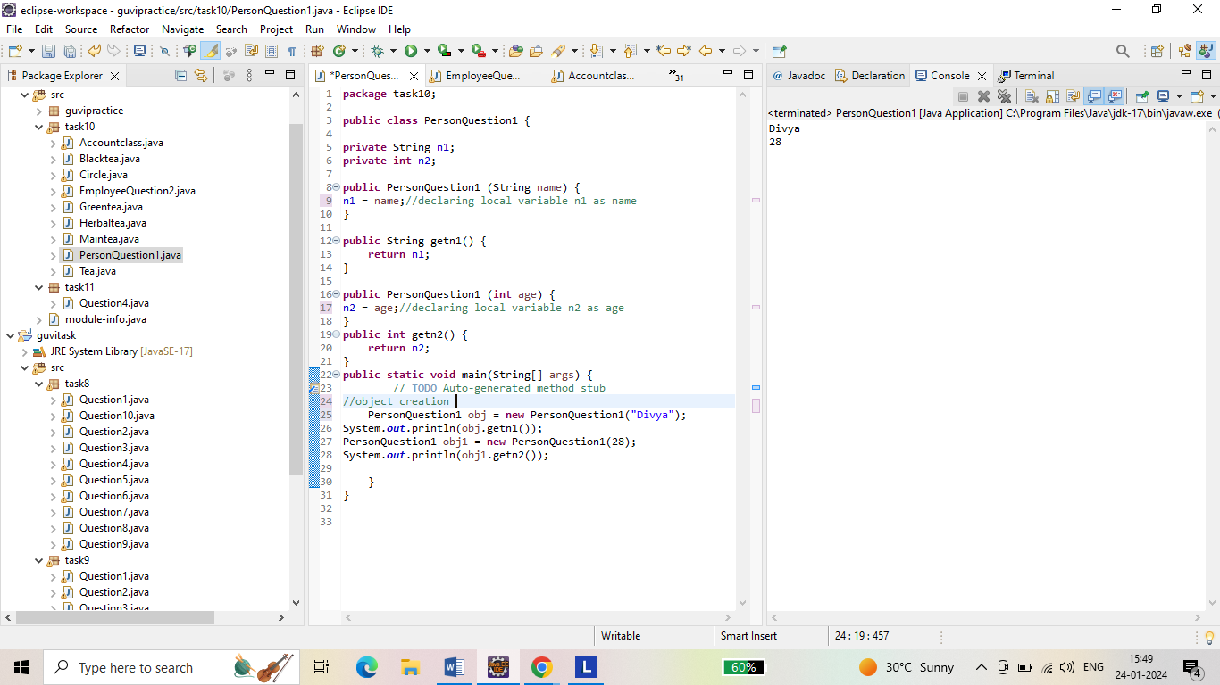

**Question 2: Output for Implementation of java class named employee.**

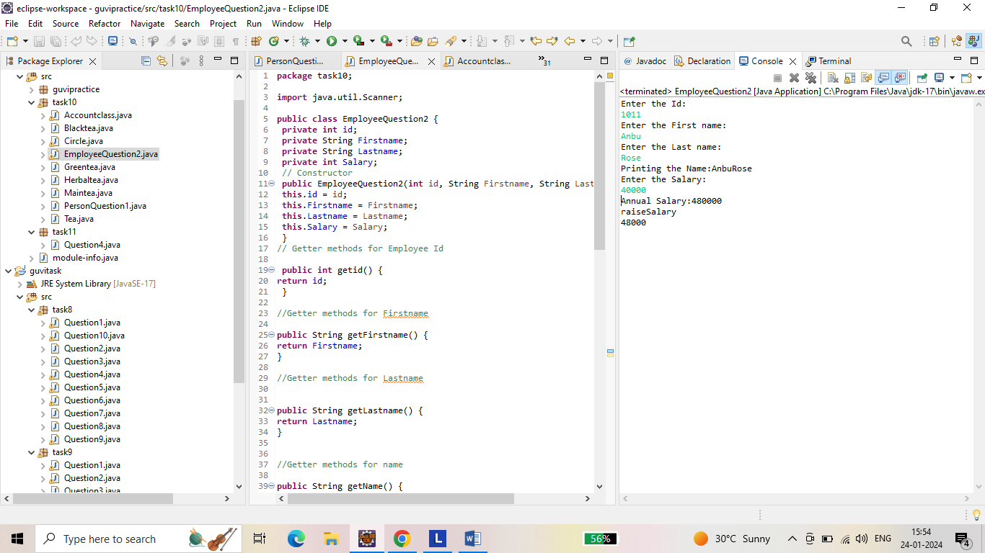

**Question 3: Output for calculating circumference of circle.**

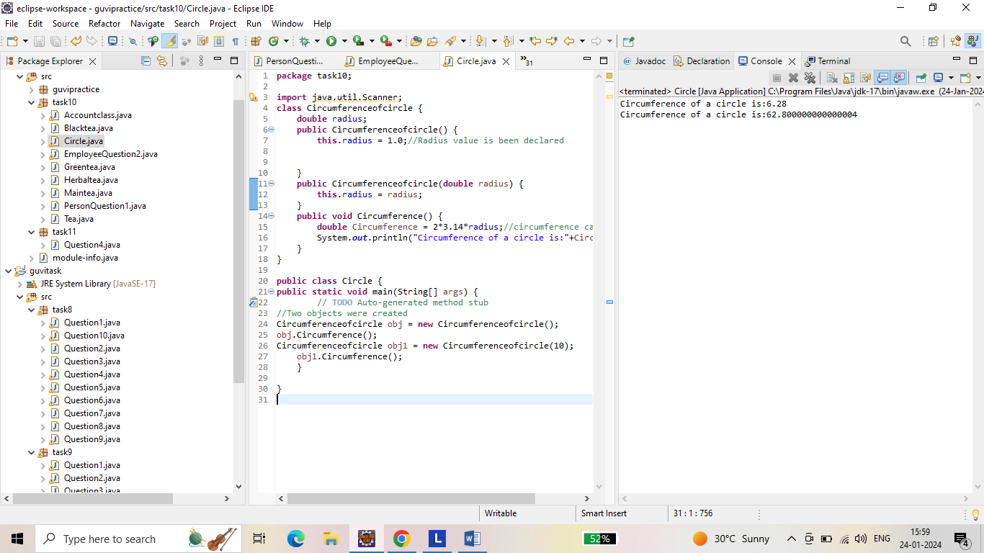

**Question 4: Output for calculating withdraw and deposit balance.**

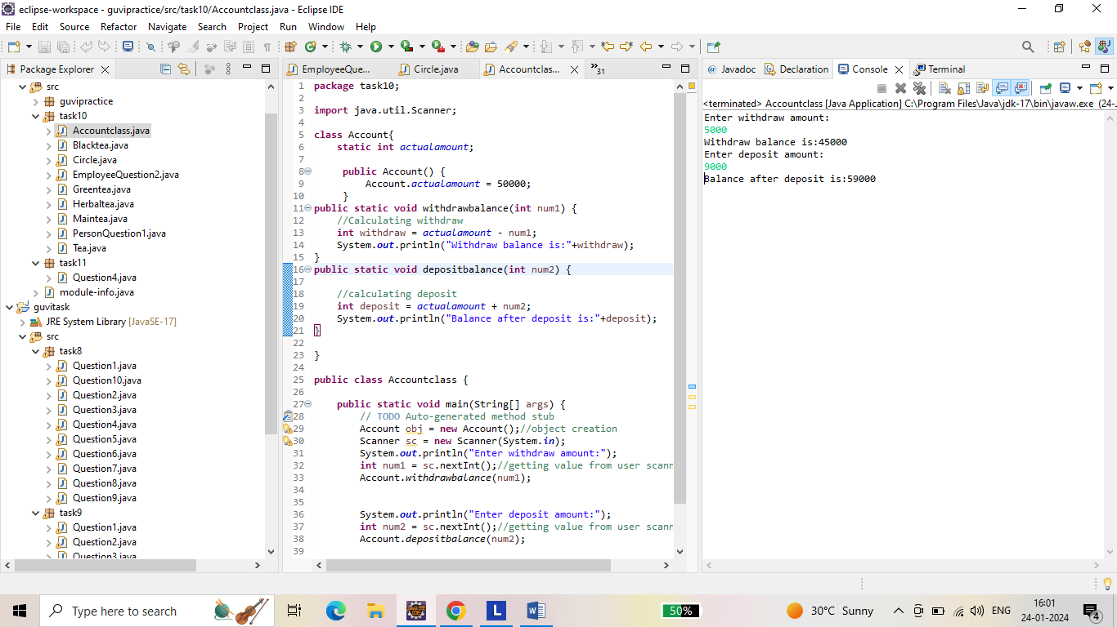

**Question 5: Output for Tea preparation by adding some given methods.**

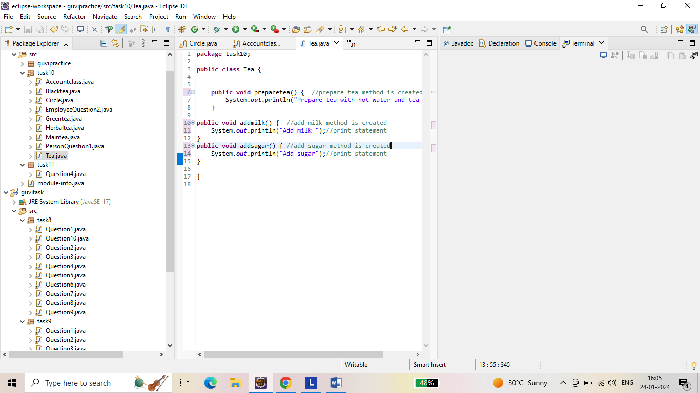

**Question 6: Output for creating 3 sub classes.**

**Tea extends sub class black tea.**

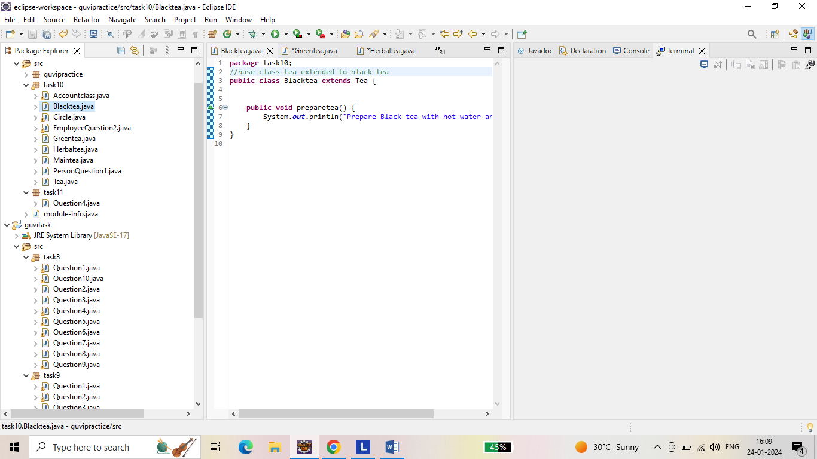

**Tea extends sub class Green tea.**

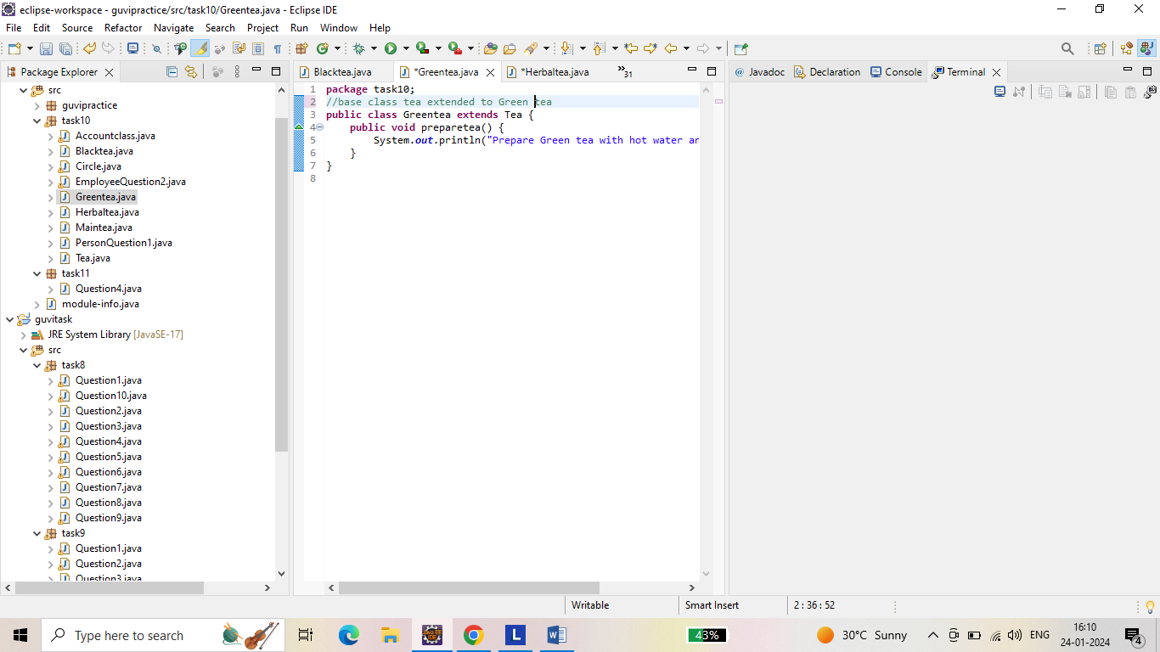

**Tea extends sub class Herbal tea.**

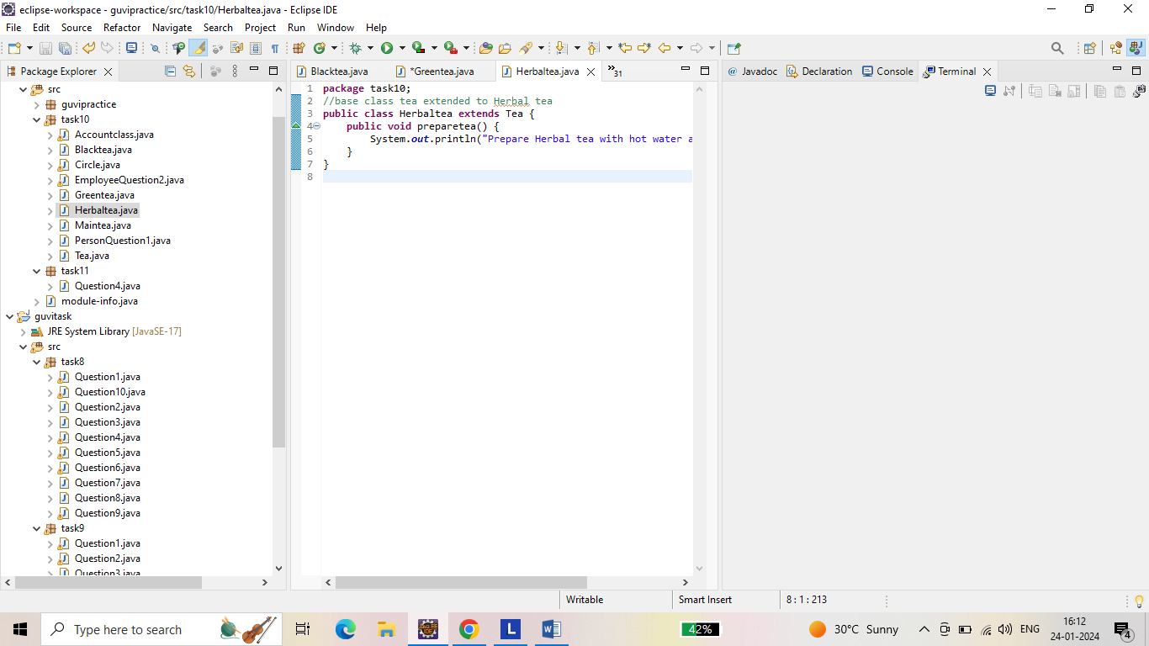

**Question 7: Output for implementation of polymorphism.**

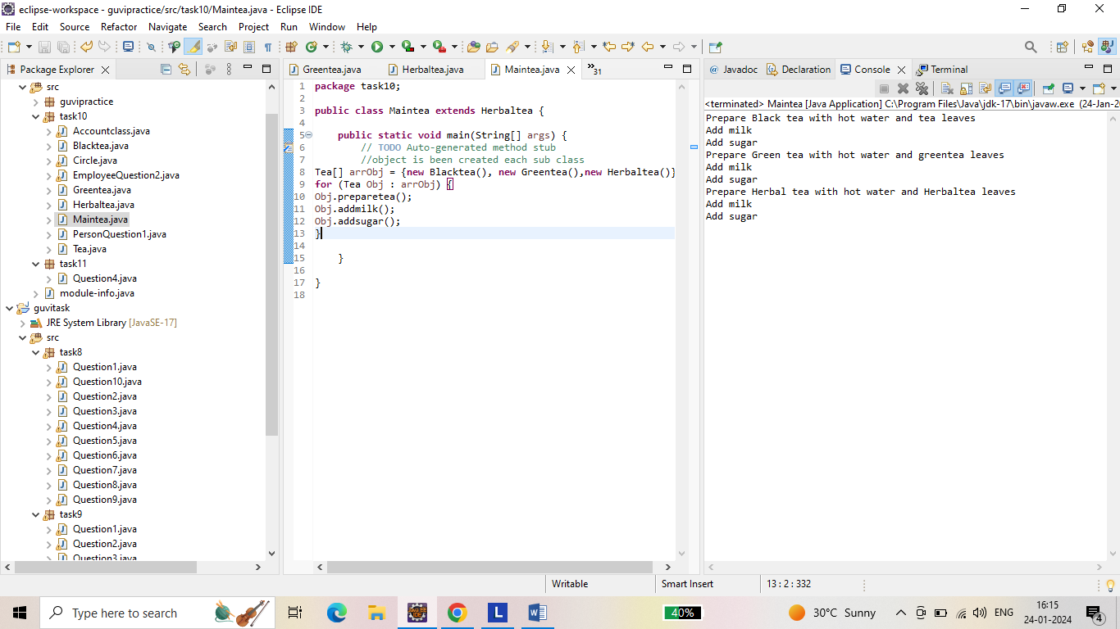

------- Thank you ------